ENGR 145 Fall 2023

Homework Set #2

Due Wednesday, Sept. 13

CR Ch. 3

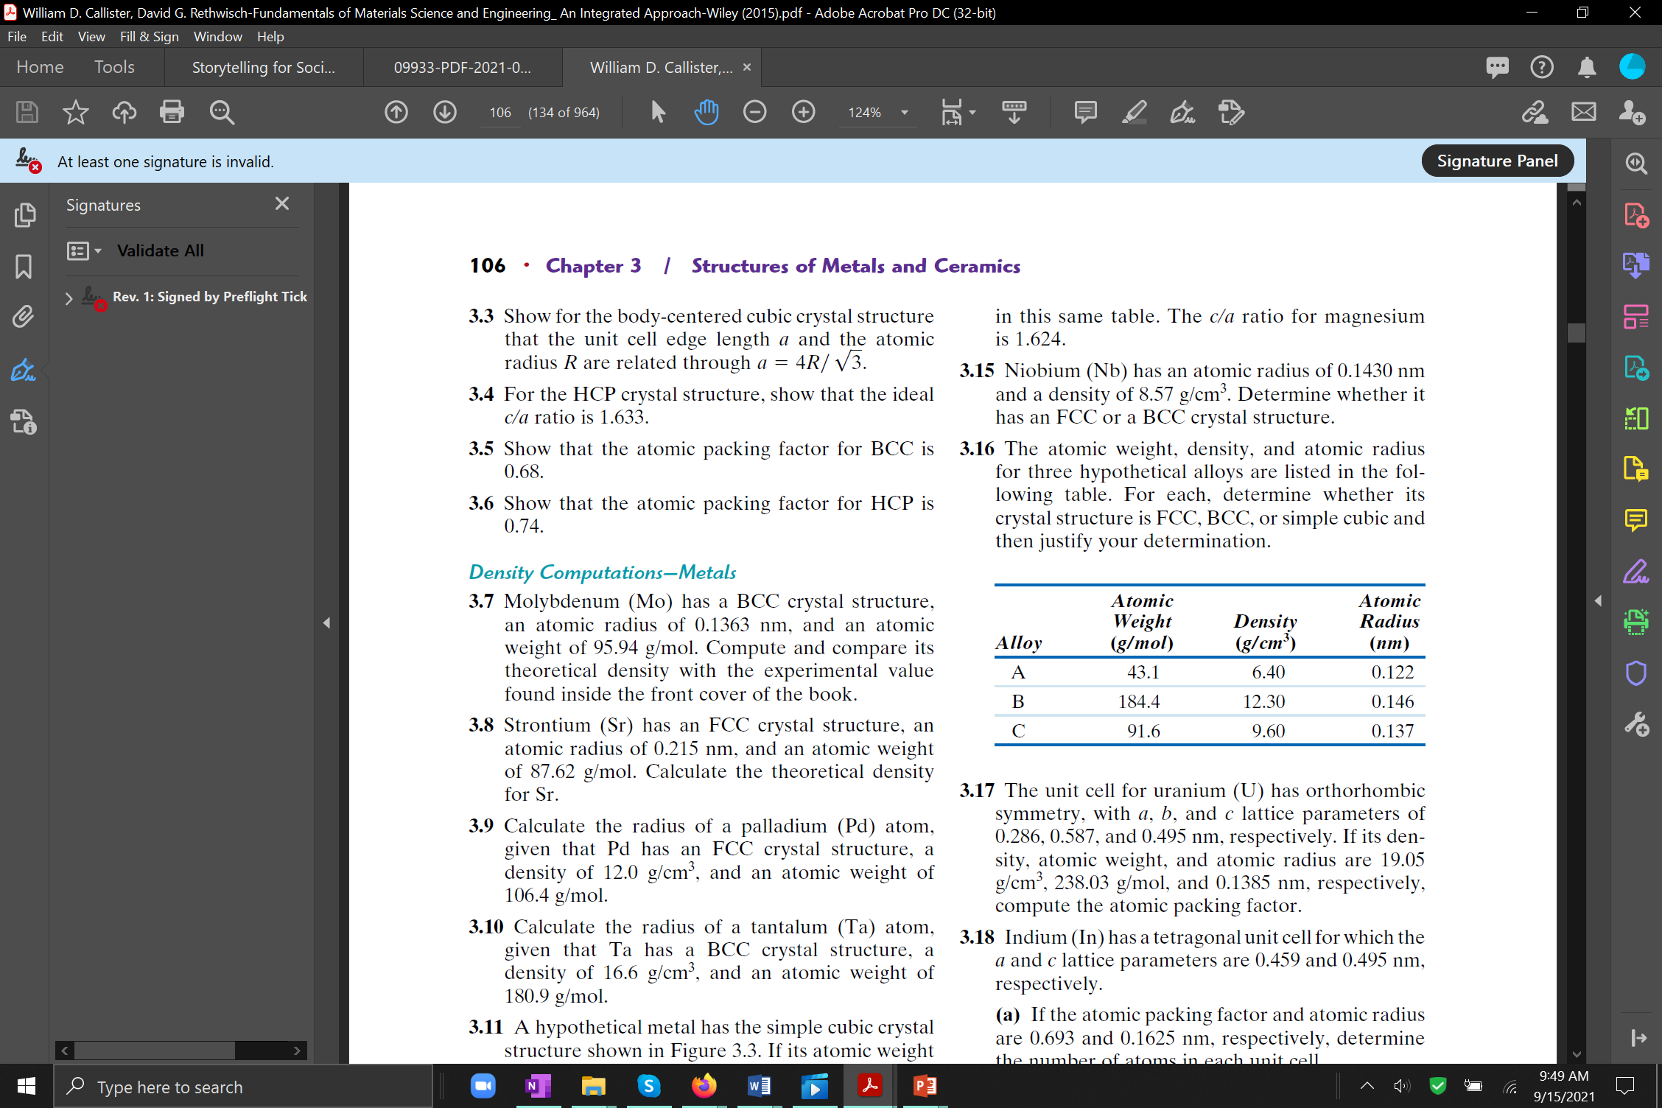

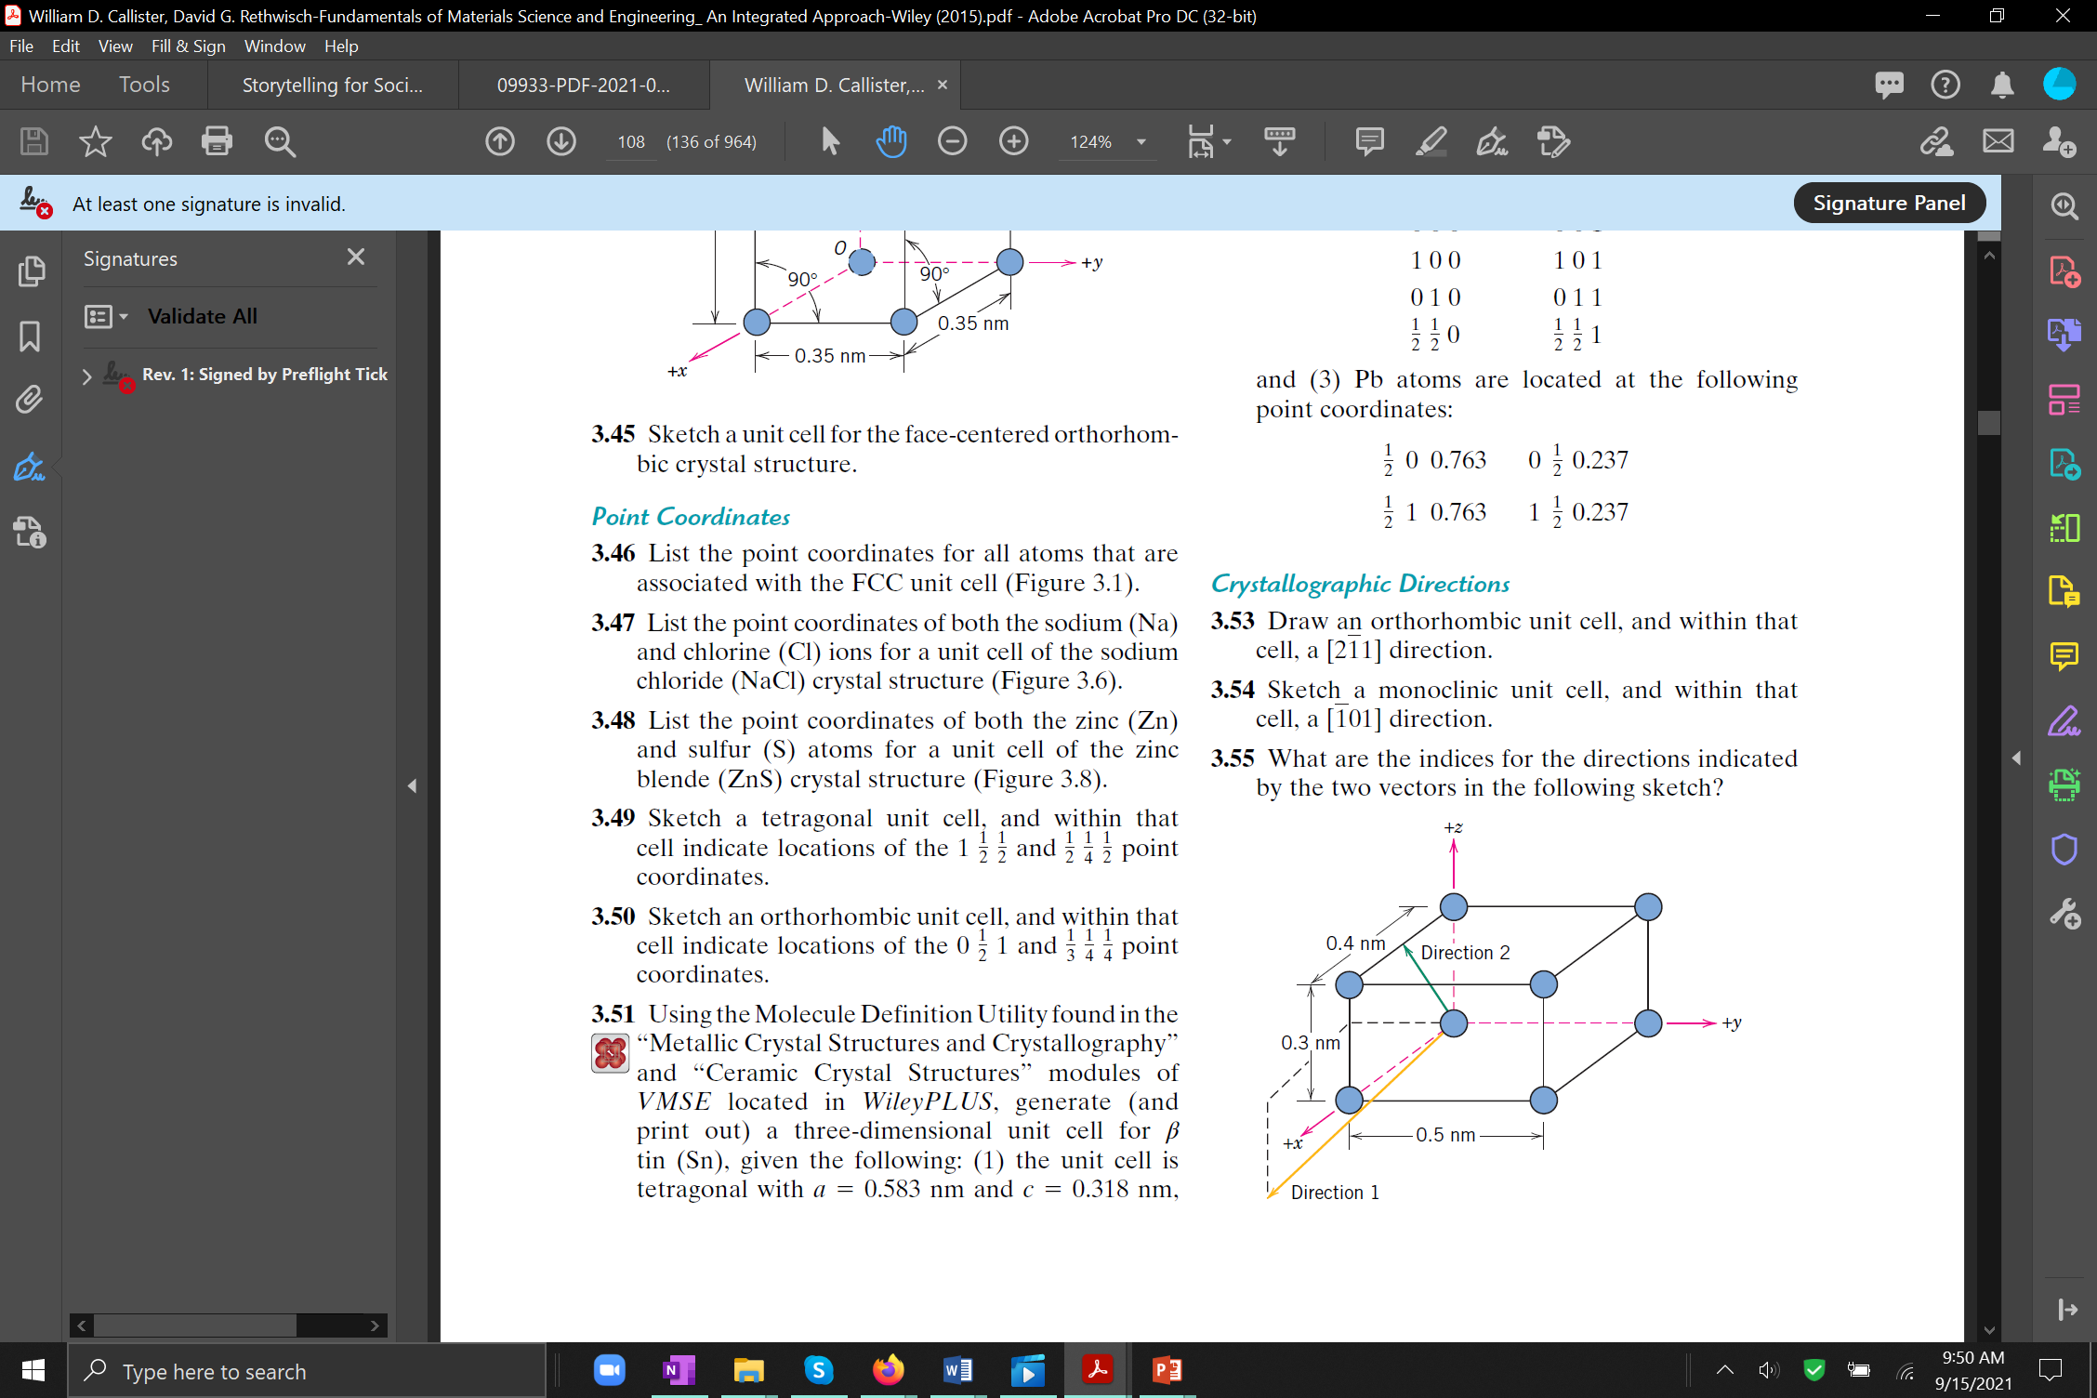

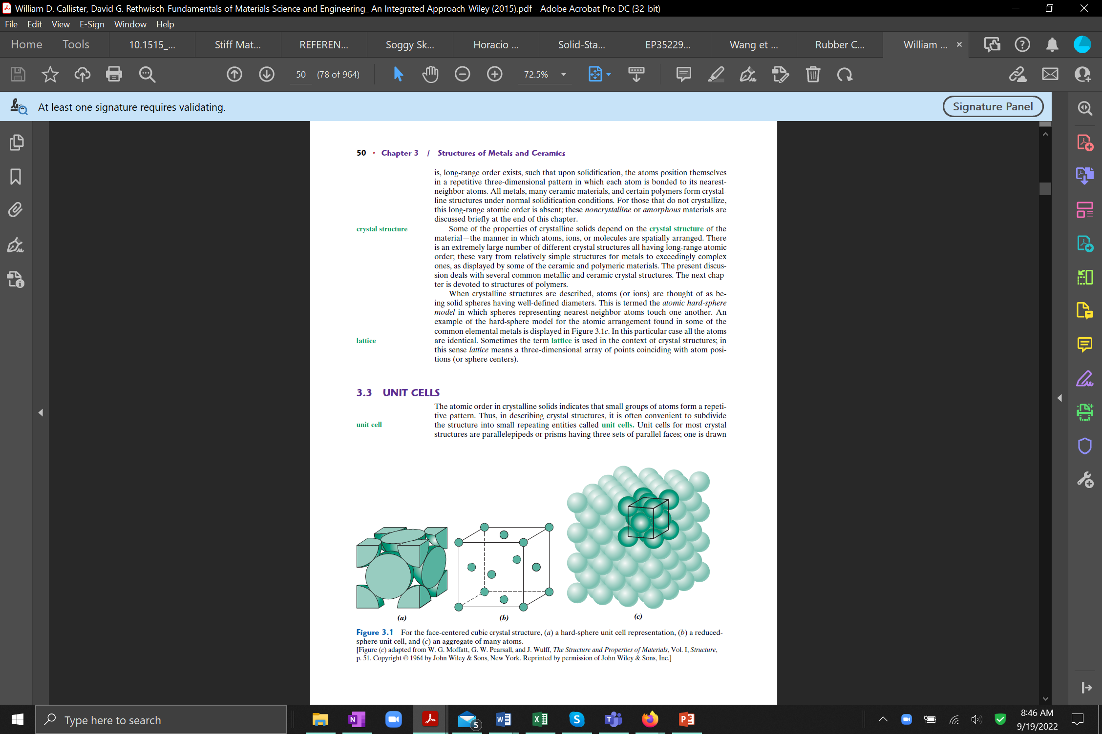

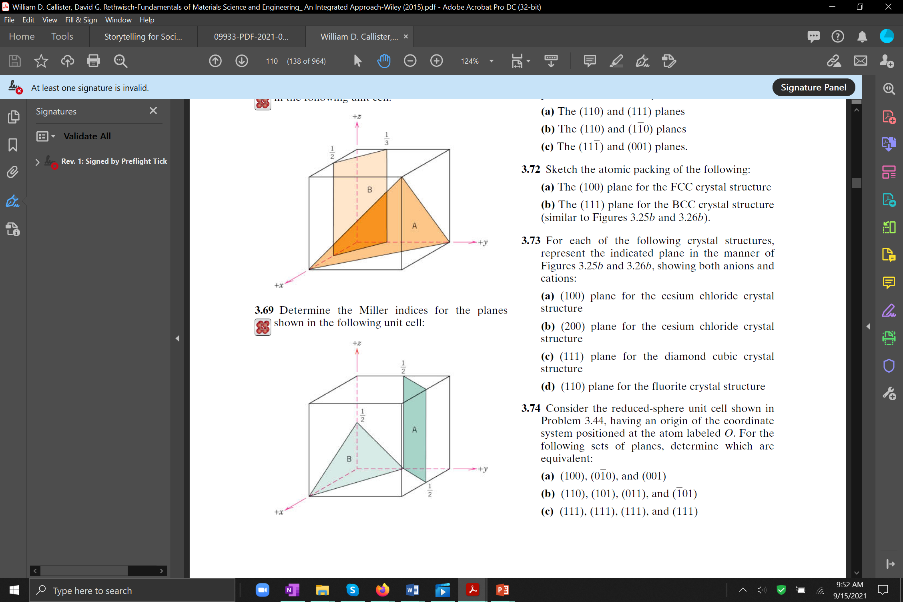

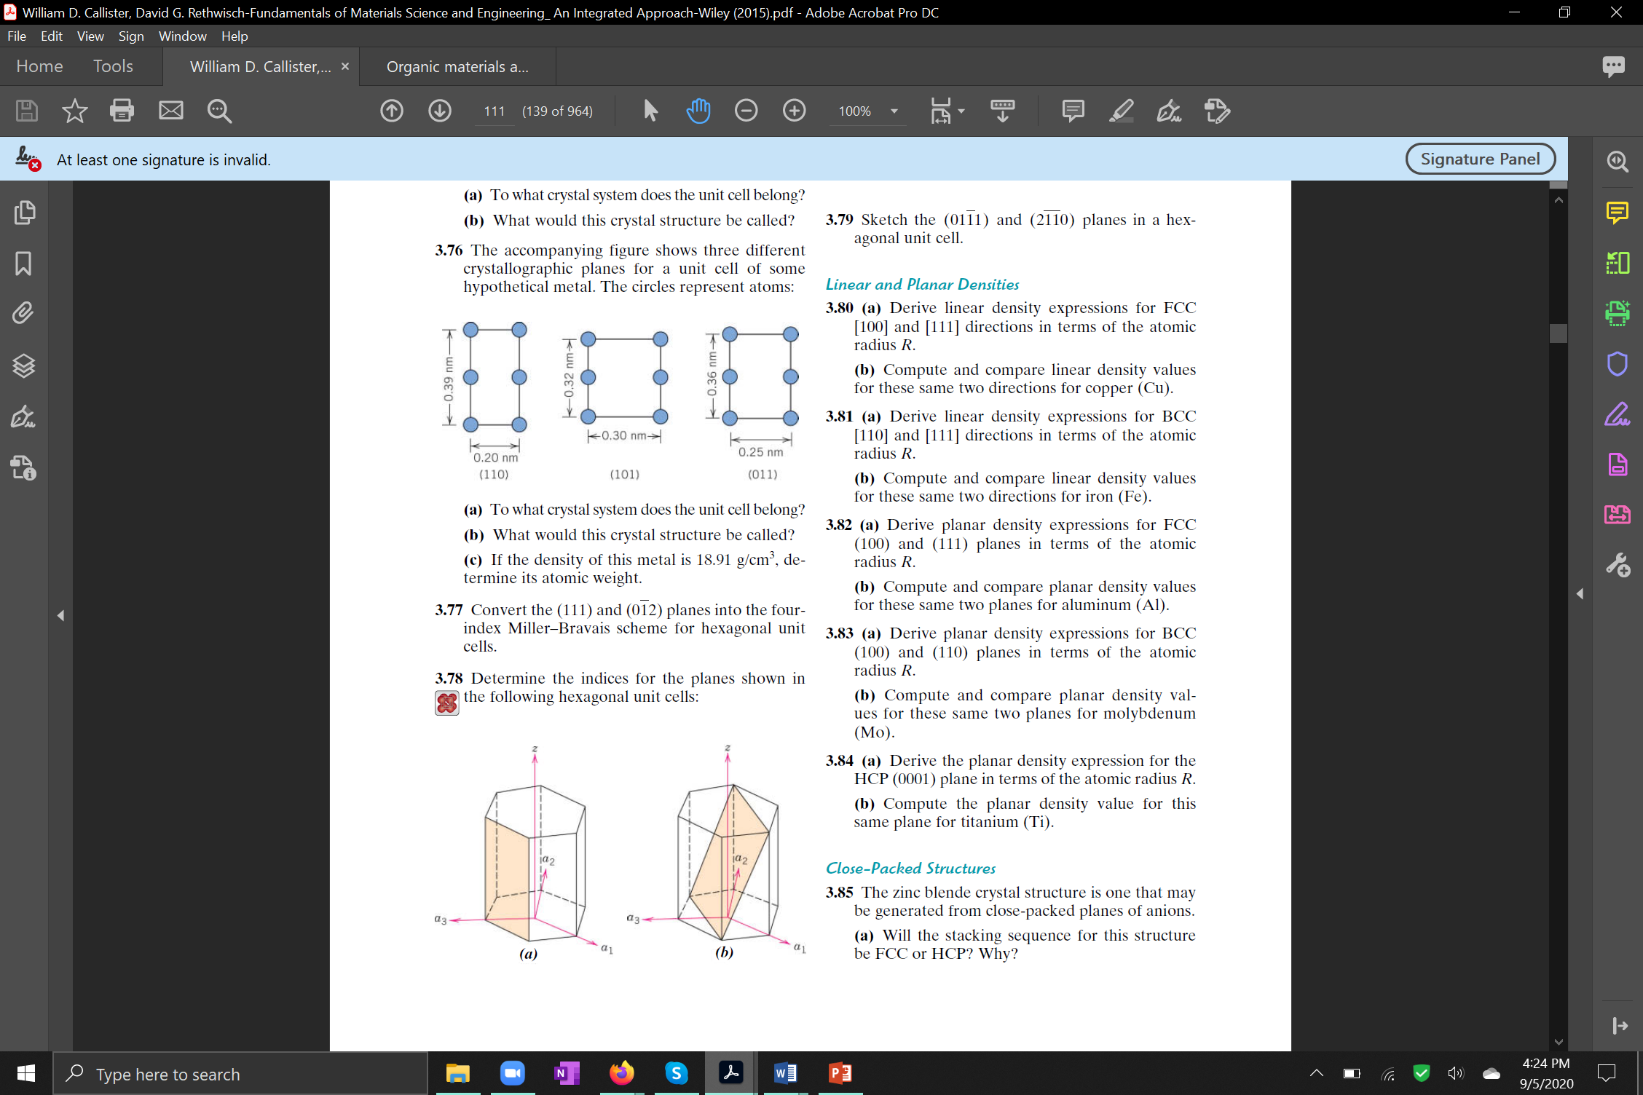

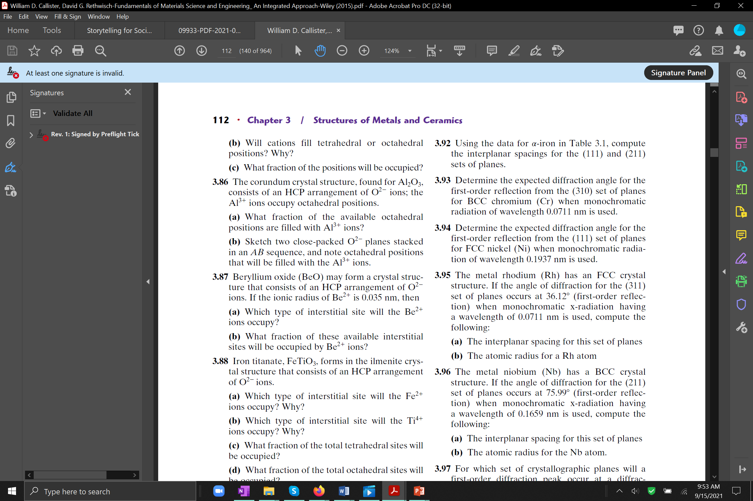

Thought question: In addition to x-rays, crystalline materials can be studied by electron diffraction. What does this say about the properties of an electron beam?